**EFFECT OF MENTAL HEALTH ON THE ACADEMIC PERFORMANCE OF STUDENTS**

**(A CASE STUDY ON FUNAAB’S STUDENTS IN ABEOKUTA SOUTH,**

**OGUN STATE)**

**BY**

**ALLI TAIWO TOSIN**

**MATRIC: 20172790**

**A PROJECT IN PARTIAL FULFILLMENT OF THE REQUIREMENT FOR THE AWARD OF BACHELOR OF SCIENCE (HONS.) STATISTICS SUBMITTED TO THE**

**DEPARTMENT OF STATISTICS COLLEGE OF PHYSICAL SCIENCES FEDERAL UNIVERSITY OF AGRICULTURE, ABEOKUTA, OGUN STATE.**

**2023.**

**DECLARATION**

I**, ALLI TAIWO TOSIN** with matric number **20172790** declare that this project “Effect of mental health on the academic performance of FUNAAB’s student’ was done by me and submitted to the Department of Statistics, Federal University of Agriculture**.**

**……………………………… ………………………………**

**ALLI TAIWO TOSIN DATE**

**CERTIFICATION**

This is to certify that this research project was carried out by ALLI TAIWO TOSIN, MATRIC NO 20172790 in the Department of Statistics, College of Physical Sciences, Federal university of Agriculture, Abeokuta, Nigeria.

(supervisor) Date

(Head of Department) Date

(External Examiner) Date

**DEDICATION**

This project is dedicated to all those who have supported, encouraged and inspired me and specially to my beloved parents( Mr and Mrs Alli), honorable lecturers and friends for their guidance, love and attention which has made it possible for me to make it up to this point.

**ACKNOWLEGEMENT**

First and foremost, I would like to thank God almighty for bringing me this far, it wouldn’t have been possible without him.

I am grateful to my supervisor (DR. Mrs Orojo), my parents who were always there, my sponsors, my siblings and my friends, I pray you will live long to eat the fruit of your labor in sound health, Amen.

My appreciation goes to my H.O.D and my lecturers for their support.

To everyone who contributed to the success of this project, a very big thank you to you all.

**ABSTRACT**

Mental health has never been taken serious but plays a very important role in a person’s life. This affects the activities of a person. A student mental health is a contributing factor to his or her academic performance. The aim of this study is to show the effect of mental health on a student’s academic performance.

Study was conducted with a quantitative descriptive survey design and simple random sample was used for the study. Online questionnaire was used to collect data for the study which was subjected to descriptive and statistical analysis (Regression and Correlation analysis) was used.

The research was conducted using structured questionnaires and the result was analyzed R programming language. This study beyond reasonable doubt reveals that mental health has an impact on the academic performance of students.

**TABLE OF CONTENT**

Title page………………………………………………………………………………………i

Certification……………………………………………………………………………………ii

Dedication……………………………………………………………………………………iii

Acknowledgement……………………………………………………………………………iv

Abstract……………………………………………………………………………………….v

Table of content……………………………………………………………………………..vi-viii

List of tables………………………………………………………………………………….ix

List of figures…………………………………………………………………………………x

**CHAPTER ONE: Introduction**

1. Background of statement………………………………………………………….1

1.1 Problem statement………………………………………………………………………3

1.3 Aim and objectives………….……………………………………………………….…3

1.4 Research questions………………………………………………………………..……4

1.6 Scope of study………………………………………………………………………….4

1.5 Limitations………………………………………………………………………………5

1.6 Definition of terms…………………………………………………………………….5-6

**CHAPTER TWO: Literature review**

* 1. Concept of Mental health……………………………………………………………7-9
  2. Factors that contribute to mental health……………………………………………….9
  3. How the location of student affect their mental health……………………………..10-11

**CHAPTER THREE: Methodology**

3.0 Research design…………………………………………………………………………12

3.1 Population of study……………………………………………………………………..12

3.2 Phase of collection …………….………………………………………………………13

3.3 Sampling technique………………………….…………………………………………13

3.4 Sample size……….……………………………………………………………………13

3.5 Method of Analysis……………………………………………………………………14-18

**CHAPTER FOUR: Results and Discussion of findings**

1. Research findings…………………………………………………………………..19

4.1 social demographic characteristics of respondent data…………………………………19-20

4.2.2 Output and interpretation…………………………………………………………21

4.2.2.1 Assumptions of multiple regression……………………………………………21

4.2.2.2 Correlation analysis……………………………………………………………….21-26

4.2.2.2 Regression analysis…………………………………………..…………………….26

**CHAPTER FIVE: Conclusion and Recommendation**

1. Summary………………………………………………………………………………
   1. Conclusion…………………………………………………………
   2. Recommendation………………………………………………………………..
   3. REFERENCES…………………………………………………………………
   4. APPENDIX………………………………………………………………………

**CHAPTER ONE**

**INTRODUCTION**

1. **Background of statement**

A person is in a state of mental health if they are aware of their own potential, are able to deal with life's usual pressures, are able to work productively and work productively, and are able to contribute to their community.

According to the World Health Organization (WHO), a few examples of what is meant by mental health include subjective well-being, reported self-efficacy, autonomy, competence, generational dependence, and self-actualization of one's cognitive and emotional potential. A human's ability to enjoy life, strike a balance between their activities and their efforts to build psychological resilience, cultural differences, and subjective evaluations of competing professional theories can all be regarded as indicators of their mental health, according to holistic viewpoints.

Our mental health consequences both how effectively we manage pressure and the amount of energy we use for regular activities. Our mental health determines how effective we are. Certain mental health problems may stem from high levels of stress, which may impair brain function and activity. Some people may just need a few hours of sleep to return to normal mental functioning, however when a person's mental health continuously has effect in his or daily life activities like work, social life, and education, he or she could work on managing it to be able to contribute positively.

While discussing mental health, factors such as emotional control, adaptability, autonomy, security-insecurity, and consciousness all come into play. When you don't have frequent mood swings and have consistent emotional responses, you are emotionally stable.

One's beliefs are discussed by one's self idea or self efficacy. It is the perception or notion we hold of ourselves. It is how we believe others will perceive our capacity to plan and carry out the actions necessary to bring about achievement.

Academic delay and dropout can be avoided in part by a student's capacity to manage emotional stress while studying.

Depression disorder symptoms include lowered mood, poor cognitive function, a lack of coping mechanisms, and a lack of interest in social interactions. Both anxiety and depression have a detrimental effect on a student's ability to engage in social and academic activities on a daily basis.

"Emotional intelligence is thought to be linked to pro-social behavior, including stress management and physical wellbeing, according to a growing body of studies. Additionally, their research revealed that people who are unable to express their emotions are more likely to engage in antisocial behavior (such as physical fighting, excessive drug or alcohol use, and vandalism), which may be a sign of mental illness and result in social stigma that can exacerbate issues.

The Institute for Health Metrics and Evaluation [IHME], 2018] reports that depression and anxiety are two of the most prevalent mental health conditions in childhood and have frequently been connected to academic achievement in adolescence.

Higher anxiety ratings were substantially connected with higher grades when both anxiety and depression levels remained associated with poorer grades. The relationship between academic success and mental health may

According to the National Longitudinal Study of Adolescent Health (n=6,315; after controlling for year of study, gender, ethnicity, family receipt of public assistance, highest level of parental education, family income, family structure, and academic aptitude), self-reported depression scores, symptoms of attention deficit/hyperactivity disorder, the frequency of delinquent behaviors, and substance abuse were all negatively correlated with high school grade point averages taken from transcripts. Academic achievement and depressed systems or the presence of a possible clinical depression disorder appear to be strongly correlated. The connection to anxiety, though, seems to be less certain.

Academic achievement and depressed systems or the presence of a possible clinical depression disorder appear to be strongly correlated. The connection to anxiety, though, seems to be less certain.

Aspects of teenage psychosocial well-being, such as life satisfaction, contentment, self-determination, and the presence of supportive social and societal relationships, have also been linked in studies to academic achievement. Despite the dual-continua model's assertion that mental illness/dysfunction and mental well-being are two distinct but related aspects of overall mental health, psychological well-being and specific symptoms of dysfunction like depression and anxiety have typically not been examined at the same time (Westerhof & Keyes, 2010; World Health Organization[who],2004). Measures of psychological well-being have been linked to this dual continua paradigm.

People have not typically given much thought to their mental health. A person's life really depends on and is greatly influenced by their mental health. There has been little to no research on the relationship between students' mental health and the educational system. They do, however, have a strong bond. It has been discovered that mental health lowers academic achievement and degree completion. Anxiety and depression are a couple of these.

**1.1 STATEMENT OF THE PROBLEM**

Most institutions don’t see a need to look into the mental health of students and how this factor affects the productivity of the student in his or her academics. Mental health problem exhibits school difficulties including poor academic achievement. Therefore, this research tends to examine the effect of mental health on the academic performance of students in Federal University of Agriculture, Abeokuta.

**1.3 GENERAL OBJECTIVES**

The general objective of this study is to determine the effect of mental health on the academic performance of students in FUNAAB

* Examine the individual challenges of students in FUNAAB which has to do with one of the factors of mental health
* Examine the academic performance and challenges student face in their academics
* Establish the relationship between their mental health and their academic performance

**1.4 RESEARCH QUESTIONS**

* What is the relationship between mental health and academic achievement?
* How do certain mental health conditions affect how people carry out their daily activities?

**RESEARCH HYPOTHESIS**

Null Hypothesis (H0): There is no significant difference between the mental health of students and their academic performance

Alternative Hypothesis (H1): There is a significant difference between the mental health of students and their academic performance.

**1.5 SIGNIFICANCE OF THE STUDY**

This study is significant because it will provide useful information to undergraduate students, university lecturers, parents, government officials and social health administration in understanding the one of the major problems undergraduate’s students in Nigeria are facing. And it will also help undergraduate students have a better academic performance.

It will also assist the government, university programs, information and orientation that would make lecturers and students work towards developing a healthy lifestyle and thereby improving their mental well being which will directly improve their academic performance.

This result will also bring to light the relationship between mental health and academic performance of student and enrich knowledge on how to have a better performance in the university programs.

**LIMITAITIONS OF THE STUDY**

The following considerations limited the study on the impact of students' mental health on their academic performance at Federal University of Agriculture Abeokuta.

1. Unwillingness of undergraduates to reveal the truth on their mental health challenges and also academic performance, as some might take this information to be confidential.
2. Inadequate financial resources which hindered the research to all the students in Federal University of Agriculture, Abeokuta.

**1.6 TERMINOLOGIES**

**• Childhood autism:** a systemic disorder that manifests before the age of three that is characterized by the existence of abnormalities and/or impaired development, as well as by the typical type of abnormal functioning in each of the three areas of social interaction, communication, and confined repetitive behavior.

**• Bipolar disorder:** Defined by episodes in which a person's mood and level of activity are markedly off-balance.

**• DEPRESSION:** Depression is a prevalent psychological disorder characterized by sadness, loss of interest or pleasure, guilt or a feeling of low self-worth, irregular eating or sleeping patterns, exhaustion, and difficulty focusing. It can be severe and make it difficult for a person to function in daily life, at work, or in school. It can also be persistent or recurrent.

**• Drug Drug Usage and Drug Disorders:** Conditions caused by varied patterns of drug use include acute sedative overdose, acute stimulant intoxication or overdose, unsafe or hazardous drug use, cannabis dependency, and their accompanying withdrawal states.

**• Intellectual disability:** : a disorder that started before maturity and affects development long-term, typified by a significantly diminished ability to understand new or challenging information, learn and use new abilities, and perform socially.

**CHAPTER TWO**

**REVIEW OF RELATED LITERATURE**

In this chapter, the information gathered ideas and postulate of authors, physical and health education experts, psychological experts as well as professionals on the field of education on the issues on the issues of mental health and their effect on academic performance are reviewed. The review shall be

-Concept of mental health

-Factors that contribute to mental health.

-How the location of students (hostels) affect their mental health

- Relationship between mental health and academic performance of students

**2.0 CONCEPT OF MENTAL HEALTH**

The first international conference on mental health was convened in London the same year that the WHO was created. At its second meeting (September 11–16, 1950), the WHO Expert Committee on Mental Health established the following definitions for "mental hygiene" and "mental health": Mental hygiene refers to any behaviors that support and preserve mental health.

MT,the first author, suggested a utilitarian understanding of mental health (Thirunavurakasu., 2011). The conception of the biological being whose health is "mental health" is essential to this idea. Manas is the name given to the entity to purposefully eliminate the dated and antiquated connotations associated with the word. Neither the manas nor any other component of the body are attributes. Manas may exist.

The manas might be in a state of well-being known as "mental wellness." The following three clinical criteria are used in the later conception.

1. Becoming conscious of one's own existence.

2. The capacity for interpersonal ties

3. All of one's acts are beneficial, or at the very least do not harm oneself or others.

The younger generation now is the greatest cohort of pupils ever. Several important changes occur between adolescence and the early years of adulthood, including ones that are monetary, housing-related, social, and emotional. Some college students find it distressing when relationships suffer during this time of transition. A significant proportion of students are reportedly describing their academic experience as psychologically difficult (Nedregard and Olsen), which is another claim that has been made. 2014 This tendency may suggest that students are finding this time period to be more demanding than in the past, and for some of them, it may be a risk factor for mental illness (Nerdrum et al., 2009). The relevance of students' mental health as a major global public health issue is underlined (Stallmann, 2008; Storie et al., 2010).

Mental health has been linked to decreased academic self-efficacy and subpar study progress, even if the underlying mechanisms are complicated and poorly understood. An American longitudinal study revealed that mental health issues predicted postponed academic progress (GPA), indicating a direct link (Eisenberg et al., 2009). Bandura (1997) similarly connected the emergence of anxiety and depression to experiences of prolonged overthinking and low self-esteem.

**2.1 FACTORS THAT CONTRIBUTE TO MENTAL HEALTH**

Poor mental and physical health is frequently caused by childhood adversity, such as abuse, parental loss, witnessing domestic violence, or household dysfunction (Heim and Nemeroff, 2001). Early adversity has a number of negative effects, including a significantly elevated likelihood of substance use, misuse, and dependency (Dube et al., 2003).

The goal of Anderson and Teicher's review (Andersen and Teicher, 2008) is to summarize some of the most recent studies on the effects of early stress on animal and human brain development, with a particular emphasis on any potential associations that could shed light on the relationships between early adversity and later alcohol, nicotine, and illicit drug abuse. Another study by Gerra et al. (2007) shows that drug users have a history of neglect as children and poor parent-child connection and may in part be responsible for a complicated neurobiological issue that affects the neuroendocrine axis and the dopamine system, both of which are crucial in the development of addiction and affective disorders.

**2.3 HOW THE LOCATION OF STUDENT AFFECT THEIR MENTAL HEALTH**

Thus according study, students' poor academic performance is caused by a difficult transition to postsecondary education (Perry, 1991). The first year of college is linked to a higher risk of mental health-related issues and, as a result, lower levels of wellbeing, in addition to a relatively high possibility of academic failure (Hunt and Eisenberg, 2010; Auerbach et al., 2018; Bruffaerts et al., 2018;Choi , 2018).

Academic success is linked to mental health and psychological well-being suffers as a result, as seen by school performance, grade, point average, and number of credits earned (Bruffaerts et al., 2018). College students with mental health concerns are twice as likely to drop out, according to Hartley (2010) and Kessler et al. (1995). Suicidal ideation and depression are additional risk factors. relates to a lower GPA (Mortier et al., 2015; De Luca et al., 2016).

Academic success and mental health are rooted in a broader view of "eudemonic" well-being as self-realization and purpose (Waterman, 1993; Ryan and Deci, 2010).

In general, mental health problems are prevalent among college students. Ten kids out of ten claim to have at least one mental health problem (HuntandEisenberg, 2010; Auerbach et al., 2018; Bruffaerts et al., 2018). In a recent study, depression disorders were found to be more common than generalized anxiety disorders among students from 19 universities across eight different countries (N=13,984) (Auerbach et al., 2018; Bruffaerts et al., 2018). Stress and ill health.

As a result, poor academic achievement and mental health problems are associated. We need to define two separate fundamental conceptions of wellbeing in order to comprehend this interconnectedness and offer solutions that do not benefit one at the expense of the other. More than one in ten undergraduates who participated in the American College Health association-sponsored National College Health (2008) survey reported having experienced depression at least once in the year prior, and nearly one in ten said they had thought about trying suicide seriously. This necessitates a serious concern for the need to further investigate this phenomenon (ACHA-NCHA, 2008).

Looking into this, it has been stated that offering counseling to the victims is possibly the most typical response to psychological issues. When we take the time to comprehend the seriousness of the issue. Many colleges have improved their counseling departments as a result of taking proactive initiatives. To address both the demand for services and the needs of students in terms of mental health, counseling facilities are recognized to employ a range of cutting-edge tactics (Kitzrow, 2003). These tactics might include making appointments more accessible and available right away, especially for students who are experiencing a crisis, by offering evening and drop-in appointments as well as phone consultations. Another significant strategy/resource that enables counseling centers to serve more students is the use of peer counselors and recently graduated interns.

**CHAPTER THREE**

**METHODOLOGY**

In this chapter, we explain how the research was carried out, how the data was gathered, the location, the population and how they were selected.

**3.0 RESEARCH DESIGN**

This study was done using quantitative descriptive survey design to derive information on the subject matter from respondent of this study.

**LOCATION**

This research was carried out in the federal university of Abeokuta (FUNAAB)

**3.1 POPULATION OF STUDY**

The study participants were students from Federal University of Abeokuta. Students from different colleges were interviewed online for this operation. This selection was made by using questionnaire and selecting those who responded. Online questioning was also done and link was sent to student’s social media platform. About 287 participants was used in conducting this analysis.

Using applied research, student behavior and experiences are both the units of analysis. Knowledge was also acquired from a thorough literature review on evidence of problems and solutions in student mental health in school settings.

Interview questions were prepared, and common themes and patterns were found in the participants’ responses.

**3.2 PHASES OF COLLECTION**

The study used the quantitative methods as well as qualitative methods of research

Collection was done through online submission. Necessary time was also given to the students to carefully answer question, care was also taken to build rapport by securing the participant’s informed consent and ensuring confidentiality.After filling in their responses online, and thereafter submitting, the responses from different students are being gathered together and put together into spreadsheets. The data was cleaned and errors such as missing data, blank spaces and so on were corrected before taking further actions.

The analysis began by putting out problems students are facing. Then their performance academically was also noted. This helped to check if this student were suffering from some mental health issues and if these issues had any effect on their academic performance.

**3.3 SAMPLING TECHNIQUE**

A multi sampling method was used. FUNAAB was purposively selected for the study. Different colleges were used in conducting this analysis.

* 1. **SAMPLE SIZE**

The population for this analysis is about 15000 students of which 289 responses was generated from the questionnaires filled.

**3.5 METHOD OF DATA ANALYSIS**  
Data collected were analyzed using inferential statistics of regression analysis and correlation analysis .R programming language was used for the analysis of the data

**Regression Analysis:** The estimation of associations between a dependent variable and one or more independent variables is done using a set of statistical techniques called regression analysis. It can be used to model how strongly the link between variables will develop in the future and to gauge the strength of the relationship between variables.

You can use regression analysis to look at how two or more relevant variables relate to one another. Although there are many different kinds of regression analysis, they always focus on how one or more independent variables affect a dependent variable. A regression equation based on a regression analysis shows the relationship between each independent variable and the dependent variable through the coefficient.

Understanding the following concepts is crucial for understanding regression analysis:

Dependent Variable: This is the primary element you're attempting to comprehend or anticipate.

• Independent Variables: These are the elements you believe will have an effect on your dependent variable.

**Assumptions for a Linear Model in Regression**

There are Six basic assumptions of linear regression analysis:

1. The slope and intercept of the dependent and independent variables exhibit a linear connection.

2. No randomness exists in the independent variable.

3. The residual (error) value is zero.

4. The residual (error) value is the same for all observations.

5. There is no correlation between the residual (error) value and any particular observation.

6. The residual values (errors) are distributed normally.

**Regression Analysis – Simple Linear Regression**

Simple linear regression is a model that assesses the relationship between a dependent variable and an independent variable. The simple linear model is expressed using the following equation:

Y=a + bX + **ϵ**

Where:

* **Y** – Dependent variable
* **X** – Independent (explanatory) variable
* **a** – Intercept
* **b** – Slope
* **ϵ** – Residual (error)

### Regression Analysis – Multiple Linear Regression

Multiple linear regression analysis is essentially similar to the simple linear model, with the exception that multiple independent variables are used in the model. The mathematical representation of multiple linear regression is:

##### Y = a + bX1 + cX2+ dX3 + ϵ

Where:

* **Y** – Dependent variable
* **X1, X2, X3**– Independent (explanatory) variables
* **a** – Intercept
* **b, c, d** – Slopes
* **ϵ** – Residual (error)

The same guidelines as the simple linear model apply to multiple linear regressions. However, there is another requirement for the model because several independent variables are present in multiple linear analysis:

• **Non Colinearity**: There should be a minimum amount of correlation between independent variables. It will be challenging to determine the genuine relationships between the dependent and independent variables if the independent variables have a high degree of correlation with one another.

A simple linear regression will be performed, since we are interested in the relationship between two variables which are mental health and academic performance. In this analysis, our dependent variable which is mental health will be compiled coding the answers gotten from student’s questionnaires. For example,

How can you rate your quality of sleep?

* Very bad
* Bad
* Normal
* Good
* Very good

Very bad will be coded as 1

Bad- 2

Normal-3

Good-4

Very good- 5

Academic performance which is the dependent variable will also be collated

##### Using the linear regression model which is Y = a + bX + ϵ

Where Y which is the dependent variable is the academic performance and X which is the independent variable is mental health

## What is correlation analysis?

A statistical technique used in research to determine the association between two variables and gauge the strength of their linear relationship is correlation analysis. The magnitude of change in one variable as a result of the change in the other is determined using correlation analysis, to put it simply. A high correlation indicates a strong association between the two variables, whilst a low correlation indicates a poor correlation between the two variables.

**CHAPTER FOUR**

**DATA PRESENTATION:**

The data collected was with a population size of about 15000 students of which 300 samples was generated

**4.0 RESEARCH FINDINGS**

With the general information of sample, the data gathered were centered on the demographic variable of respondents and this includes their sex, age, colleges, marital status, educational qualifications and research objectives

**4.1 SOCIAL DEMOGRAHIC CHARACTERISTICS OF RESPONDENT DATA**

**Age group of Respondents**



**Gender of respondent**

|  |  |
| --- | --- |
| **Row Labels** | **Count of Gender** |
| Female | 117 |
| Male | 110 |
| **Grand Total** | **227** |

**Sponsor of respondent**

|  |  |  |  |
| --- | --- | --- | --- |
| **Count of Gender** | **Column Labels** |  |  |
| **Row Labels** | **No** | **Yes** | **Grand Total** |
| **Female** | **87** | **30** | **117** |
| Others | 6 | 1 | 7 |
| Parent | 75 | 27 | 102 |
| Self | 6 | 2 | 8 |
| **Male** | **79** | **31** | **110** |
| Others | 4 | 1 | 5 |
| Parent | 66 | 28 | 94 |
| Self | 9 | 2 | 11 |
| **Grand Total** | **166** | **61** | **227** |

**DATA ANALYSIS**

The analysis was carried out using R programming language. Statistical tools regression and correlation was used to analyze the data. Here is the R code used for the analysis.

**4.2.2 OUTPUT AND INTERPRETATION**

**4.2.2.1 Assumptions of multiple regressions**

Multicolinearity Test

Variables Tolerance VIF

1 Economic stability 0.8065747 1.239811

2 Relationship 0.8460602 1.181949

3 Finances 0.9654374 1.035800

4 Academic challenges 0.9759984 1.024592

5 Sleep & eating Habit 0.9098600 1.099070

Interpretation:

Since the tolerance is high the variables are uncorrelated and therefore, multicollinearity does not exist.

Normality of the Residuals

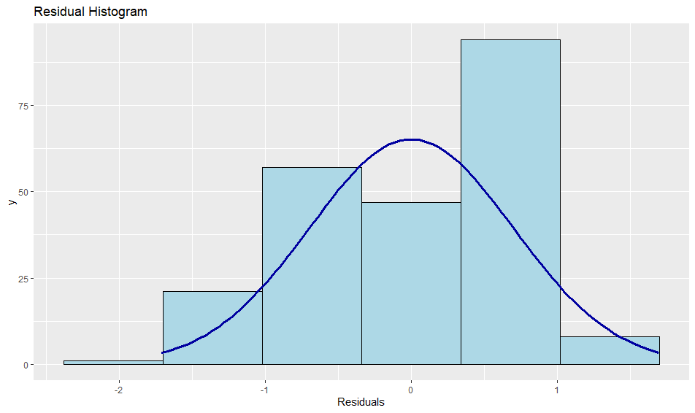

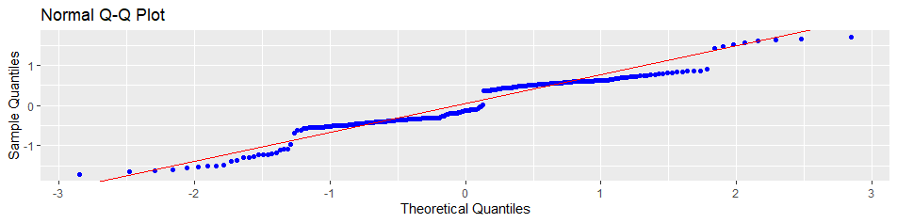

Interpretation:

The residual histogram and Q-Q plots shows that the residuals are normally distributed

Outlier Diagnostics:

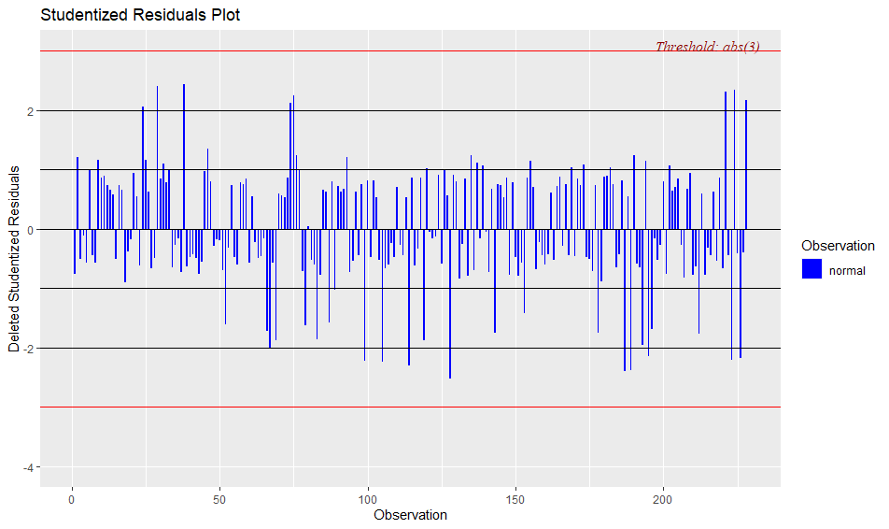

Interpretation:

The plot above shows no outlier in the data

Independence Test

lag Autocorrelation D-W Statistic p-value

1 -0.04518696 2.067111 0.586

Alternative hypothesis: rho! = 0

Interpretation:

The p-value is large, indicating that there is no autocorrelation

Linearity Test

Rainbow test

data: Reg_model

Rain = 1.1459, df1 = 114, df2 = 108, p-value = 0.2379

Interpretation:

The p-value is high so we conclude that the data fits a linear model

Homoscedasticity Test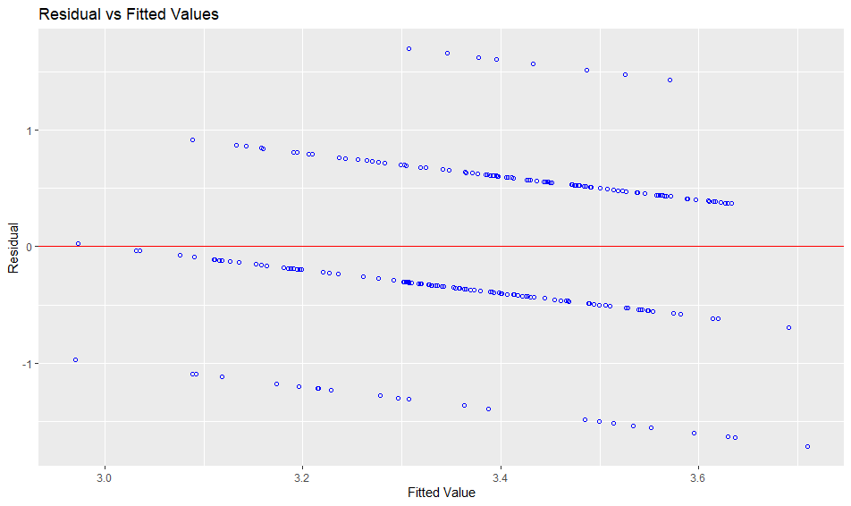

Interpretation:

In the Residual vs fitted value plot, the residuals form an approximate horizontal band around the zero line indicating the homogeneity of error variance.

studentized Breusch-Pagan test

data: Reg_model

BP = 7.4348, df = 5, p-value = 0.1903

Interpretation:

Since the p-value is large, the variance is unchanging in the residual. Therefore, there is homoscedasticity of variance.

**4.2.2.2**

Correlation:

Aperf Estab Rel Achal Finances SEHa

Aperf 1.00000000 -0.13300978 0.16147440 0.06390663 0.07406743 0.10621927 **Regression Analysis**

Regression Model

Call:

lm(formula = Aperf ~ Estab + Rel + Finances + Achal + SEHa, data = data)

Coefficients:

(Intercept) Estab Rel Finances Achal SEHa

2.75819 -0.10985 0.09868 0.07614 0.09980 0.09418

Interpretation:

The multiple regression model is given as:

Y = β0 + β1X1 + β2X2 + β3X3 + β4X4 + β5X5

From the analysis above the following model is derived;

Y = 2.75819 + -0.10985X1 + 0.09868X2 + 0.07614X3 + 0.09980X4 + 0.09418X5

Where:X1 represents emotional stability

X2 represents relationship

X3 represents financial stability

X4 represents academic challenges

X5 represents sleeping and eating habit

**Correlation Analysis**

Estab -0.13300978 1.00000000 -0.38414916 0.01551069 -0.01731066 -0.26027509

Rel 0.16147440 -0.38414916 1.00000000 -0.05623226 0.04731068 0.12957184

Achal 0.06390663 0.01551069 -0.05623226 1.00000000 0.11563022 0.05844359

Finances 0.07406743 -0.01731066 0.04731068 0.11563022 1.00000000 -0.11665794

SEHa 0.10621927 -0.26027509 0.12957184 0.05844359 -0.11665794 1.00000000

Interpretation:

There is a low negative correlation between academic performance and emotional stability.

There is a low positive correlation between academic performance and relationship health.

There is a low positive correlation between academic performance and academic challenges.

There is a low positive correlation between academic performance and finances.

There is a low positive correlation between academic performance and sleeping and eating habit.

**CHAPTER FIVE**

**CONCLUSION AND RECOMMENDATIONS**

**5.0 CONCLUSION**

Based on the findings, it could be concluded that the mental health of students in FUNAAB has an effect on their academic performance. Emotional instability has a strong effect on the academic performance of students.

**5.1 RECOMMENDATIONS**

The results emphasize the necessity to detect external and internal factors at early stages and continuously throughout the school years. In practice, it means that these kinds of problems need to be noticed in universities and educational practices adjusted and adequate treatment given to promote transition to the school environment and completion of compulsory school.

University students should also learn to manage their academics with other activities so as to be able to balance studying and other life activities.

I also recommend that further studies should be carried on this topic to create awareness

Institutions manage and run an efficient health education system to help student reduce their stress level and manage the educational activities with their individual challenges.  
Student can also learn to manage their mental health, cope with pressuring activities and their and perform better academically.

Overall, this research will help build a healthy plan or strategy in the institution, which quality is highly decisive regarding the management of the academic performance of student, coupled with their social life and daily activities.

**REFERENCES**

Eaves L.J., *et al.,* (2016). The relationship between education and mental health: new evidence from a discordant twin study. Soc Forces 95(1):107–131  
Johnson J.G., *et al.,* (2001). Inter-generational longitudinal study of social class and depression: attest of social causation and social selection models. Br J Psychia-try Suppl 40:84–90  
 Ansseau M., *et al.,* (2014) The downward spiral of mental disorders and educational attainment: a systematic review on early school leaving. BMC Psychiatry 27(14):237  
Fletcher J.M., *et al.,* (2010). Adolescent depression and educational attainment: results using sibling fixed effects. Health Econ 19:855–871

Metzger M., *et al.,* (2016). Early school adjustment and educational attainment. Am Educ Res J  
53(4):1198–1228  
Moffitt T.E., *et al.,* (1996). Behavioral observations at age 3 years predict adult psychiatric disorders. Longitudinal evidence from a birth cohort. Arch Gen Psychiatry 53:1033–1039  
Moffitt T.E., *et al.*, (1999). Low socioeconomic status and mental disorders: a longitudinal study  
of selection and causation during young adulthood. Center for Demography and Ecology University of Wisconsin, Wisconsin

American College Health Association., (2008). American College Health Association–National College Health Assessment: Reference Group Data Report, Spring 2008. American College Health Association, Baltimore, MD 2008.

A.P.A., ( 2013). College students’ mental health is a growing concern, survey finds. Vol 44, No. 6. June 2013.

Blanco, C*., et al*., Mental health of college students and their non-college-attending peers: results from the National Epidemiologic Study on Alcohol and Relate

Conditions. Arch Gen Psychiatry. 2008; 65: 1429–1437

Kadison*., et al*., (2004). College of the overwhelmed: The campus mental

health crisis and what to do about it. San Francisco, CA: Jossey-Bass.

Ibrahim., et al., (2017). Stressors and Mental Health of Students at Private University in Malaysia. Behavioral & Social Sciences Librarian

Kitzrow., *et al.,* (2003). The Mental Health Needs of Today’s College Students: Challenges and Recommendations. NASPA Journal, Vol. 41, no. 1, Fall 2003.

866 Social Psychiatry and Psychiatric Epidemiology (2021) 56:857–8661 3

Koupil I., *et al.,* (2012). School performance and hospital admission due to unipolar depression: a three-generational study of social causation and social selection. Soc Psychiatry Psychiatr Epidemiol47(10):1695–1706

Patalay P., *et al.,* (2018). Longitudinal pathways between mental health difficulties and academic performance during middle childhood and early adolescence. Br J Dev Psychol 36(1):110–126

Tiemeier H., *et al.,* (2016).The bidirectional pathways between internalizing and externalizing problems and academic performance from 6 to 18 years. Dev Psychopathol 28(3):855–867

Schweitzer J., *et al.,* (2009).The impact of early behavior disturbances on academic achievement in high school. Pediatrics 123(6):1472–1476

Kaiser K., *et al* .,(2004).Childhood emotional and behavioral problems and educational attainment. Am Sociol Rev69(5):636–658

Sydsjö G., *et al*., (2017). A biopsychosocial approach to risk and resilience on  
behavior in children followed from birth to age 12. Child Psychia-  
try Hum Dev 48(4):584–596

Sagovsky R., *et al*., (1987).Detection of postnatal depression. Development of the 10-item Edinburgh Postnatal Depression Scale. Br J Psychiatry 150:782–786

Emilin W.M.A.W., *et al*., (2015). Magnitude and risk factors for postpartum symptoms: a  
literature review. J Affect Disord 175:34–52

Achenbach T.M., *et al.,* (1992). Manual for the Child Behavior Check list/2-3 and 1992 profile. University of Vermont, Department of Psychiatry, Burlington

Gillberg C*., et al.,* (2005).The prevalence of child-psychiatric disorders among 8–9-year-old childrenin Danish mainstream schools. Acta Psychiatr Scand 111:59–67

**APPENDIX**

**R code**

library(readxl)

data<-read_excel(file.choose())

View(data)

library(jtools)

library(olsrr)

library(moments)

library(lmtest)

library(carData)

library(car)

# Parameters for the Regression output

confidence_level<- 0.95

output_digits<- 4

# Regression Model

Reg_model<- lm(Aperf ~ Estab + Rel + Finances + Achal + SEHa, data = data)

Reg_model

# Unstandardized Results

summ(Reg_model, confint = TRUE, ci.width = confidence_level, digits = output_digits)

# Standardized Results

summ(Reg_model, scale = TRUE, transform.response = TRUE, digits = output_digits)

#Assumptions of multiple regression

# Multicolinearity Test

ols_vif_tol(Reg_model)

# Normality of the Residuals

ols_plot_resid_hist(Reg_model)

ols_plot_resid_qq(Reg_model)

# Outlier Diagnostics

ols_plot_resid_stud(Reg_model)

# Independence Test

durbinWatsonTest(Reg_model)

# Linearity Test

raintest(Reg_model)

plot(Reg_model$residuals)

# Homoscedasticity Test

ols_plot_resid_fit(Reg_model)

bptest(Reg_model)

gqtest(Reg_model, order.by = ~ Estab + Rel + Finances + Achal + SEHa, data = data, fraction = 0)